Government Post Graduate College, Dwarahat
(Affiliated to Soban Singh Jeena University, Almora)
NAAC Accredited with Grade “B⁺”
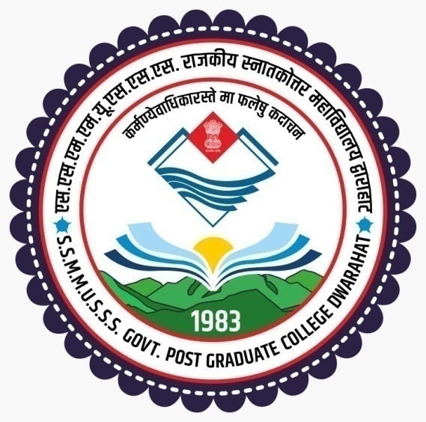

REPORT OF ANALYSIS OF PARENTS’ FEEDBACK SURVEY
SESSION-2024-25

Tabular analysis of Parents’ Feedback Survey Report 24-25
S.N. | Name of Question | Opinion of Answer |  |  |  |  | Scale of Opinion | % of Opinion
S.N. | Name of Question | Excellent | Very  good | Good | Average | Need Improvement | Scale of Opinion | % of Opinion
1. | The Teaching Learning process in Institution | 9.7% | 26.1% | 51.7% | 7.3% | 5.2% | Excellent to need improvement | 100%
2. | Academic regularity | 9.4% | 25.2% | 52.3% | 8.5% | 4.6% | Excellent to need improvement | 100%
3. | Transparency in evaluation and assessment | 9.4% | 26.4% | 50.5% | 10.6% | 3.1% | Excellent to need improvement | 100%
4. | Counselling and Guidance provided by Faculty | 17.9% | 27.4% | 46.5% | 6.1% | 2.1% | Excellent to need improvement | 100%
5. | Overall development of your ward | 12.8% | 29.8% | 47.7% | 6.4% | 3.3% | Excellent to need improvement | 100%
6. | Teaching Learning process | 12.25% | 22.8% | 52.3% | 9.4% | 3.25% | Excellent to need improvement | 100%
7. | Infrastucture Facilities | 8.5% | 19.5% | 51.4% | 31.1% | 7.6% | Excellent to need improvement | 100%
8 | Departmental Infrastructure | 10.5% | 16.1% | 54.4 % | 14% | 5% | Excellent to need improvement | 100%
9 | Laboratories Infrastructure and facilities | 10% | 23.20% | 48.30 | 10.9% | 7.6% | Excellent to need improvement | 100%
10. | Sports facilities | 13.7% | 26.1% | 45% | 9.1% | 6.1% | Excellent to need improvement | 100%
11 | NCC/NSS/Rovers Rangers/Red Cross activities | 16.7% | 31.6% | 40.1% | 7.6% | 4.0% | Excellent to need improvement | 100%
12 | Grievance Redressal process | 11.6% | 23.4% | 48% | 10.6% | 6.4% | Excellent to need improvement | 100%

Summary of Responses

